Mauricio X. Torres

CIT 230

03/02/18

**Website Planning Document**

**Site Name:** How´s today looking?

**Author:** Mauricio X. Torres

**Site Purpose**

The purpose of this site is to provide the visitors important and accurate information related to the weather of Franklin, Springfield, and Greenville cities.

**Target Audience**

Men and women older than eighteen and younger than sixty years old with a bachellor degree and with interest in information related to the cities of Franklin, Springfield and Greenville.

**Site Map.**

**Color Scheme**

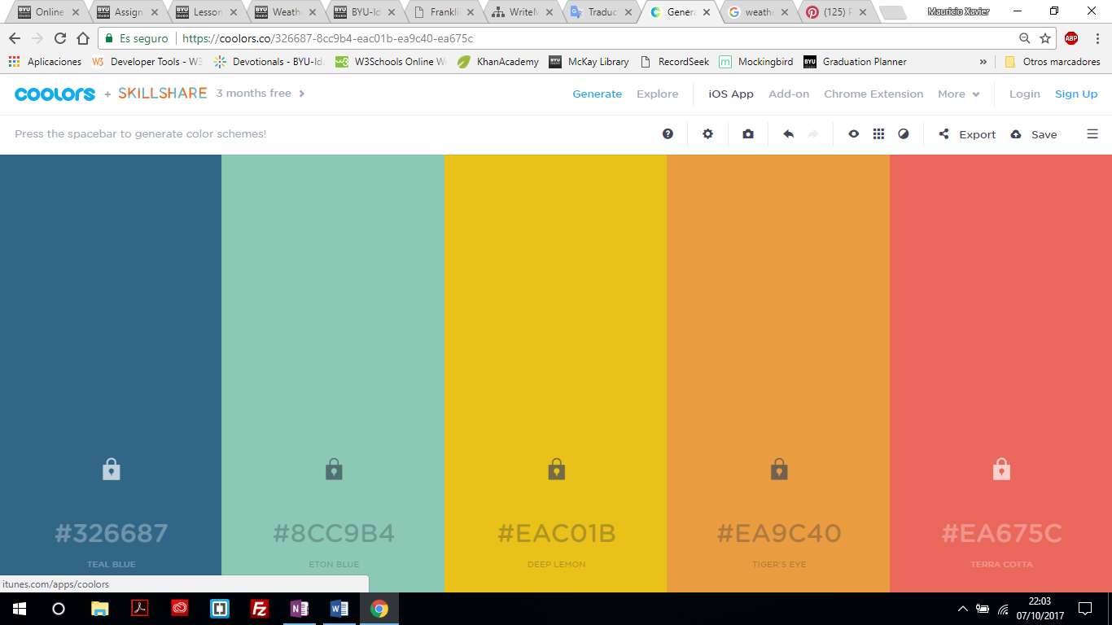

 Background Navigartion Bar

Weather Data box Hover LInks

Clicked links

**Typography**

The typography used will be Arial and Georgia.

|  |  |  |  |
| --- | --- | --- | --- |
| Site header | Arial | 40px | #EA9C40 |
| Primary Navigation | Arial | 30px | #EACO1B |
| Footer navigation | Arial | 25px | #326687 |
| H1 | Georgia | 30px | #000000 |
| H2 | Georgia | 25px | #000000 |
| H3 | Georgia | 20px | #000000 |
| Paragraph text | Arial | 18px | #000000 |

**Wire-Frame sketches**

Small View

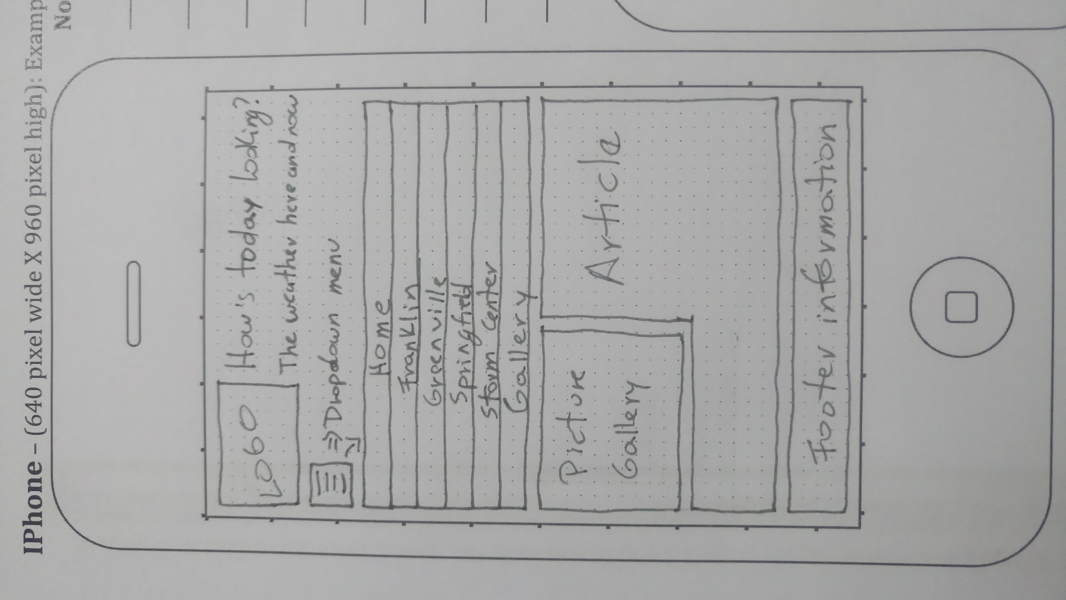

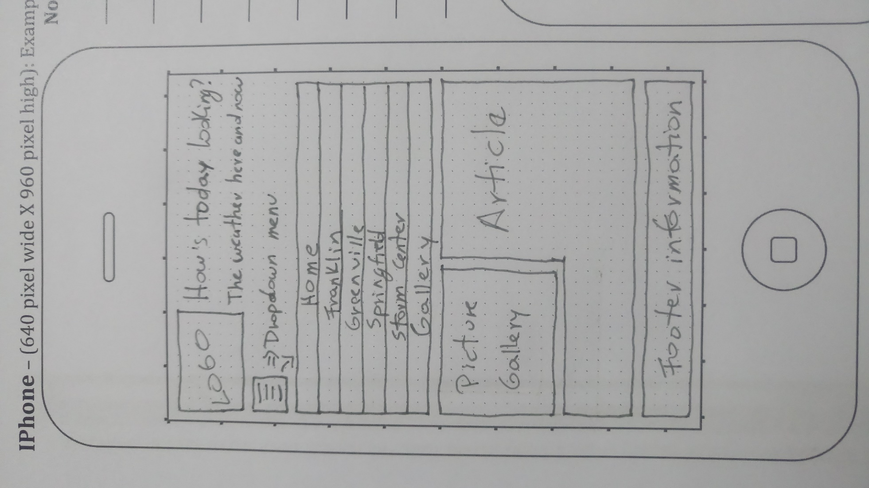

Medium View

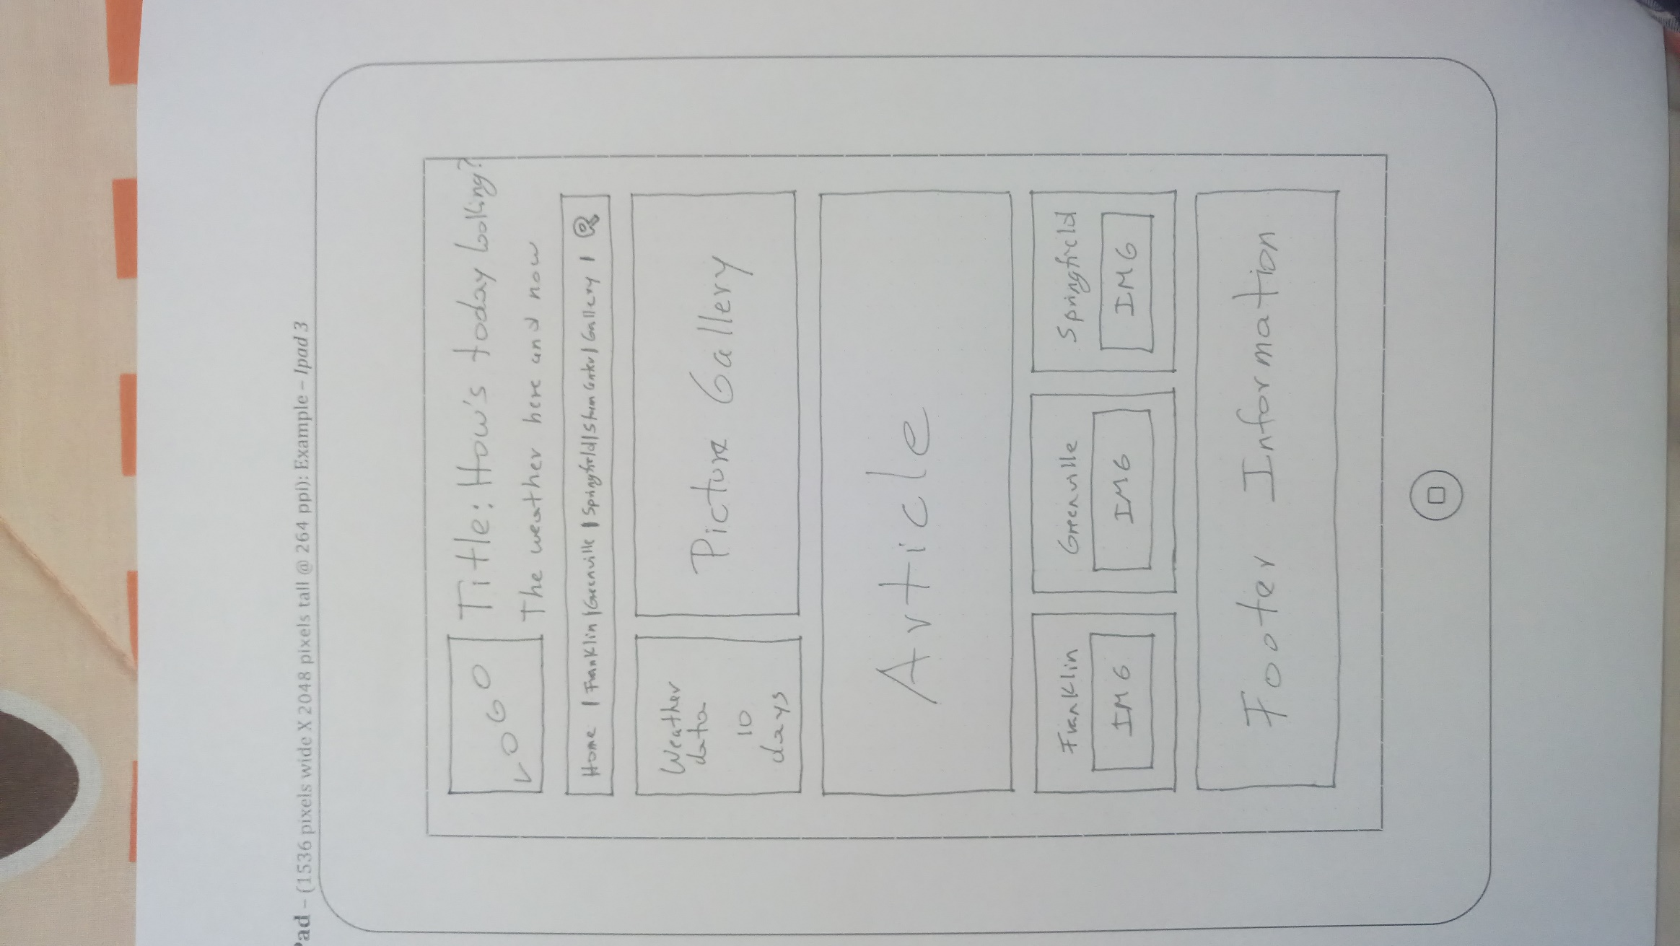

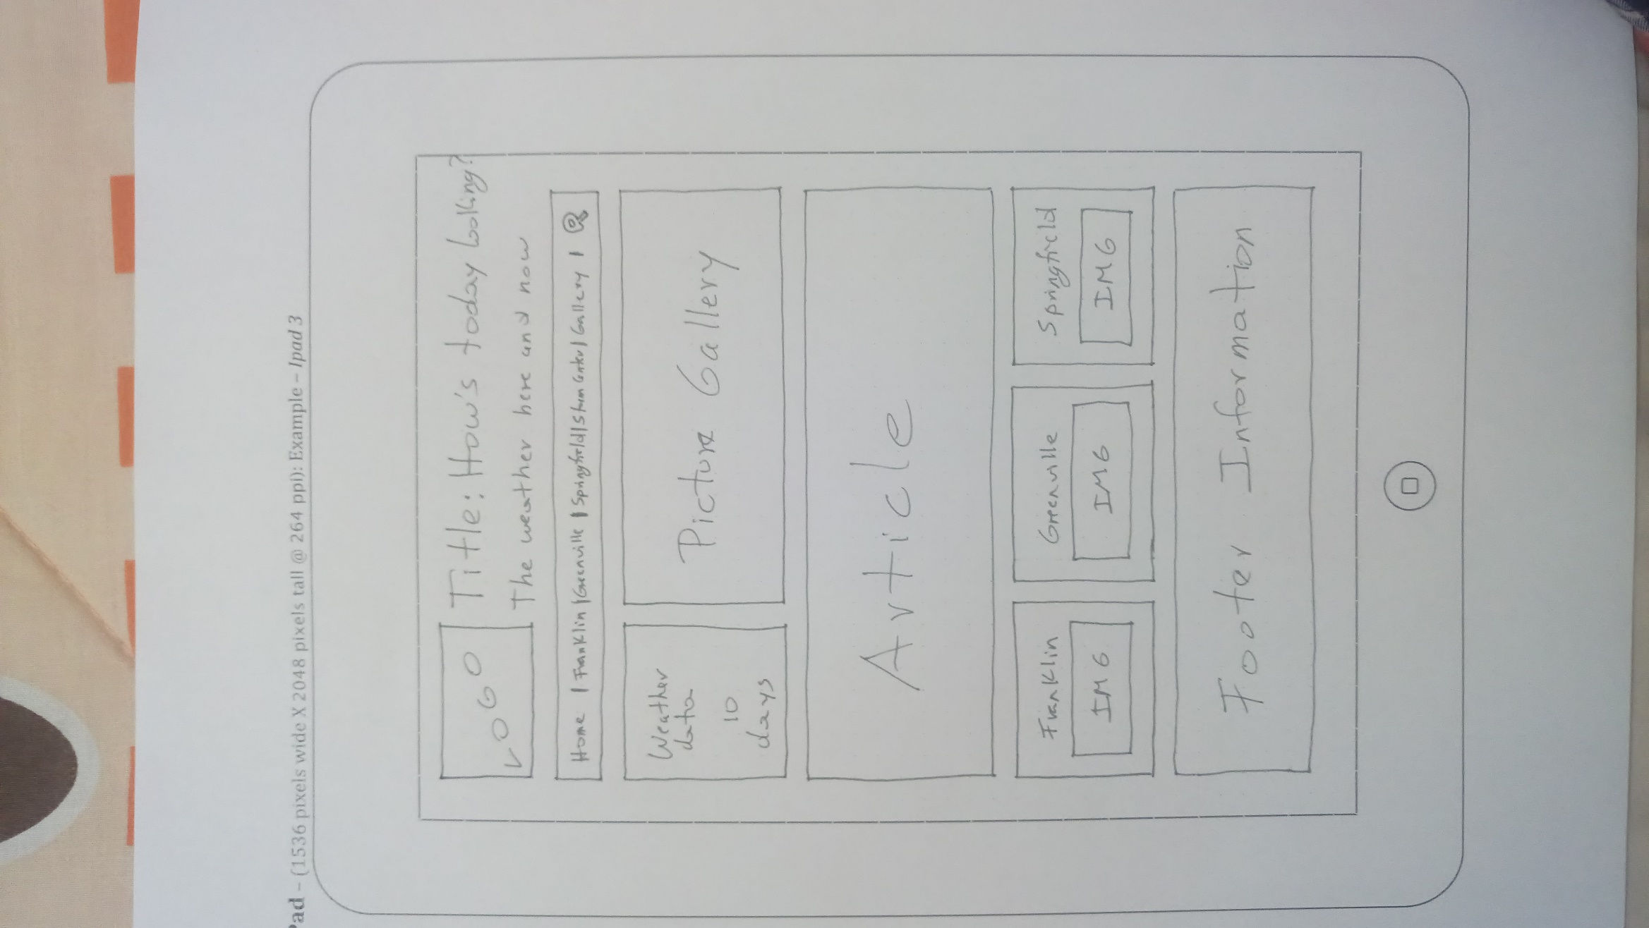

Large View

